**Unity ML-Agents Toolkit: Static Obstacles**

**PAO OBSERVATION**

Based on my work from Assignment C0, I evaluate the performance of my agent on a 50x50 plane and PAO increased:

Mean PAO for 10x10 board, with 50 instance-run was: **3.86%**

Mean PAO for 50x50 board, with 50 instance-run was: **29.33%**

Reason of increasing PAO was larger board, Agent was trained for 10x10 board, and when it scaled 5x agent routes was not enough efficient. I added the following reward to fix that issue:

*float bonus = 2 * (100 - Mathf.Min(100, currentPAO())) / 100.0f; //Give Bonus for shortest route*

And PAO reduced to **14.75%**, that optimisation helped ML agent in travelling on board with the shortest route. Average PAO for 50 cases with static obstacles (for 10x10 board) was **35.28%.**

**Training for a board with Obstacles**

For navigation, the main difficulty was the shape of our player: Cylinder, so for rotation I placed 2 child object inside that cylinder, leftSide obj and rightSide obj, and used forced on them.

I used the same approach for managing obstacle objects as I used for the Target object and for falling from the board. Whenever Player hits or stays too long in front of obstacle It gets the negative reward.

**Observations**

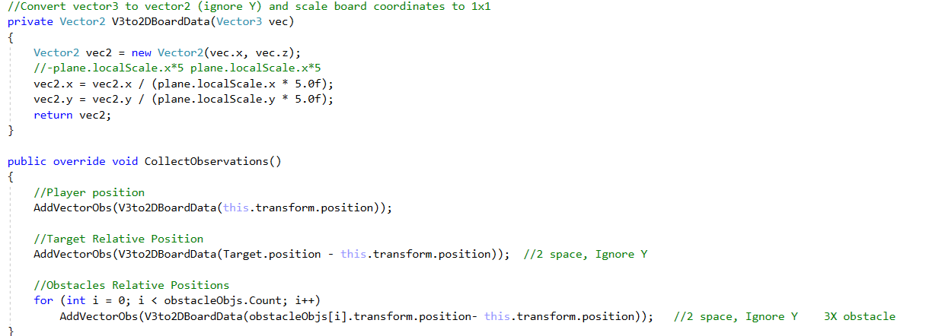

I used 8 space system for training. We just needed player position and all other objects relative positions to the player, but also scaled - as floor dimension changes.